DICEBET – DEMO
Architecture and Requirements Documentation
TABLE OF CONTENTS
- Introduction, Proposal, and Technologies
- Architecture, Design Patterns, and Purposes
- Requirements, Business Rules, Use Cases, and Screens
- Database Modeling and Data

Introduction, Proposal, and Technologies
This project is a demonstration betting platform for Web, iOS, and Android, created with the purpose of simulating the main workflows of a real-money gaming product — from user registration and wallet management to provably-fair gameplay and payment processing — while operating exclusively with virtual coins and Stripe in test mode. No real money is involved at any point.
Although simplified, the platform demonstrates production-grade concerns: an append-only financial ledger with atomic balance movements, cryptographically verifiable game results (commit–reveal), keyless cloud deployments, and a fully automated CI/CD pipeline covering API, web, and mobile builds, device testing, and distribution.
Developed as a monorepo, the platform includes the following technologies and integrations:
- Nuxt 3 (Vue 3 + TypeScript) – single-page web application, shared by web and mobile;
- Express (TypeScript) – game/API server, single source of truth for all business logic;
- Supabase – PostgreSQL database, authentication (ES256 JWT), and Row Level Security;
- Stripe Checkout + Webhooks (test mode) – simulated deposits with signature verification;
- Capacitor 8 – native Android and iOS shells around the same web build (iOS via CocoaPods);
- Firebase Crashlytics – native crash reporting plus webview JS error forwarding;
- Firebase Test Lab – automated robo tests on real virtual devices in CI;
- Firebase App Distribution – automatic delivery of each build to testers;
- Google Cloud Run – containerized API with scale-to-zero (Artifact Registry, Secret Manager);
- Cloudflare Workers – global static hosting of the web application;
- GitHub Actions – CI/CD with keyless deployments via Workload Identity Federation.

The API uses the zod (validation), jose (JWT/JWKS verification), and stripe libraries, with Vitest for automated tests. The web application implements internationalization (English, Brazilian Portuguese, Spanish) and theming (blue, purple, orange) with no external libraries, and synthesizes all game sounds with the Web Audio API — the deliverable ships zero audio assets. Git was used for version control, hosted on GitHub.
[GitHub Actions – API deploy pipeline]
[GitHub Actions – Mobile pipeline: Test Lab + App Distribution]

Architecture, Design Patterns, and Purposes
A server-authoritative architecture was adopted: one API serves both the web and mobile clients, and no game-critical logic ever runs on a client. This guarantees:
- Integrity: every balance movement flows through a single atomic PostgreSQL function (place_bet / apply_deposit) with row locking. The wallet balance is derived state that always equals the sum of an append-only transactions ledger — a crash or retry can never lose or duplicate money;
- Verifiability: game results use a commit–reveal scheme (provably fair). The server commits to sha256(serverSeed) before any bet; each roll is HMAC-SHA256(serverSeed, clientSeed:nonce); rotating seeds reveals the old one so every past roll can be re-verified client-side;
- Security: user tokens are verified against Supabase's public JWKS (ES256); Row Level Security restricts clients to owner-only reads with explicit minimal grants; all secrets live in GCP Secret Manager; CI deploys are keyless (Workload Identity Federation locked to the repository);
- Testability: the game engine (payout math, roll derivation) is pure and isolated, covered by deterministic unit tests including a statistical uniformity check and a house-edge invariant;
- Scalability: the API is stateless in a container (Cloud Run autoscales from zero), the web app is static files on a global CDN, and the database concentrates all consistency guarantees.

The client codebase is shared across platforms: the same static Nuxt build is deployed to Cloudflare and wrapped by Capacitor for Android and iOS. Cross-cutting concerns follow lightweight composable patterns — an i18n composable with per-locale dictionaries, CSS-variable theming switched via a data attribute, and a Crashlytics bridge that forwards webview errors to native reporting only when running inside the mobile shell.

Requirements, Business Rules, Use Cases, and Screens

Non-Functional Requirements (NFR) – General

NFR01 – Performance
API endpoints must respond within 500 ms (p95, warm instance). The roll animation must hold 60 fps on mid-range devices; game sounds are synthesized in real time with no asset loading.

NFR02 – Security
User sessions use asymmetric ES256 JWTs verified via public JWKS. All tables enforce Row Level Security (owner-only reads; writes exclusively through the API service role). Secrets are stored in GCP Secret Manager; webhooks are signature-verified; the client never computes or influences results.

NFR03 – Architecture and Scalability
The API must be stateless and containerized, autoscaling from zero on Cloud Run. A single API must serve web and mobile clients identically (CORS-scoped). The web application must build to static files deliverable from CDN edge.

NFR04 – Fairness and Auditability
Every game result must be cryptographically verifiable by the player (commit–reveal, HMAC-SHA256). Every balance change must be recorded in an append-only ledger satisfying the invariant balance = Σ transactions.

NFR05 – Availability
The system relies on managed platforms (Cloud Run, Cloudflare, Supabase). A health endpoint enables monitoring; deployments are gated by automated tests in CI.

NFR06 – Usability and Accessibility
The interface offers three languages (auto-detected from the browser) with a flag-based selector, three color themes, sound mute, and respects the operating system's reduced-motion preference. Layouts are responsive from mobile to desktop.

NFR07 – Software Quality
The game engine must maintain unit test coverage of payout math and roll derivation, including determinism, bounds, statistical uniformity, and house-edge tests. All code is typed (TypeScript); tests gate every deployment.

NFR08 – CI/CD and Deployment
Automated pipelines must build, test, and deploy the API (Docker → Artifact Registry → Cloud Run) and web app on every push, and for mobile: build the APK, run Firebase Test Lab robo tests on virtual devices, distribute via Firebase App Distribution, and validate the iOS CocoaPods build on macOS runners. All Google Cloud access is keyless (WIF).

NFR09 – Compliance (Demonstration)
The platform must operate exclusively with virtual coins and Stripe test mode, displaying a permanent disclaimer. It is not a gambling product and must not process real money.

Application Features
- User Registration (with welcome bonus)
- User Authentication/Login
- Dice Game – Place a Bet
- Deposits (Stripe test mode)
- Bet History
- Provably-Fair Verification (seed rotation)
- Language and Theme Selection
- Logout

User Registration
Functional Requirements
- The system must allow account creation with email and password;
- A profile, a wallet, and a $10.00 welcome bonus (virtual coins) must be provisioned automatically upon registration;
- The username defaults to the email prefix.
Business Rules
- Email must be unique and valid;
- Password must contain at least 6 characters;
- The welcome bonus is recorded as a ledger deposit with a unique reference, so it can never be granted twice.
Use Case
A guest creates an account to play with virtual coins.
Main Flow:
- User accesses the application and selects "Sign up";
- User provides email and password;
- Supabase Auth creates the account; a database trigger provisions profile, wallet, and the welcome bonus transaction atomically;
- User is redirected to the game screen with a $10.00 balance.
Alternative Flows:
- Email already registered → the system displays an error message;
- Password below minimum length → the system displays an error message.
Related Screens:
[screenshot]

User Authentication/Login
Functional Requirements
- Allow registered users to authenticate with email and password;
- Create an authenticated session (ES256 JWT issued by Supabase Auth);
- Attach the access token to every API request as a Bearer token.
Business Rules
- Only registered users may log in;
- Invalid credentials must display an error message;
- Expired sessions must require a new login; the API rejects invalid or missing tokens with HTTP 401.
Use Case
A registered user logs in to access the game and their wallet.
Main Flow:
- User enters email and password on the Login screen;
- Supabase Auth validates the credentials and issues the session tokens;
- The application loads the wallet balance from the API;
- User is redirected to the game screen.
Alternative Flows:
- Invalid credentials → the system displays an error message;
- Missing/expired token on an API call → the client redirects to the Login screen.
Related Screens:
[screenshot]

Dice Game – Place a Bet
Functional Requirements
- Allow choosing a win chance (target) between 1% and 98% via slider;
- Display the payout multiplier (99 / target, a 1% house edge) and potential win in real time;
- Animate the roll (tumbling die, number ticker, cup-shake sound) for 1.4 s before revealing;
- Settle the bet atomically and update the balance immediately.
Business Rules
- The bet wins when roll < target; the roll is in [0, 100) with two decimals;
- Stake must be positive, limited to $1,000.00 per bet, and never exceed the balance;
- The roll is derived exclusively on the server: HMAC-SHA256(serverSeed, clientSeed:nonce);
- Nonces are claimed atomically so concurrent bets can never reuse one;
- Winning pays floor(stake × 99 / target) cents; fractions round in the house's favor;
- Users with reduced-motion preference see results immediately (no suspense animation).
Use Case
An authenticated user places a bet on the dice game.
Main Flow:
- User sets win chance and stake and presses "Roll";
- The client starts the animation and sends the bet to the API with the session token;
- The API verifies the token, claims the next nonce, and computes the roll from the committed seed;
- The place_bet function locks the wallet, debits the stake, records the bet, credits any payout, and updates the balance — in one transaction;
- The animation completes; the result and the new balance are displayed with a win/lose sound.
Alternative Flows:
- Insufficient balance → the system suggests making a test deposit;
- Invalid stake or target → the system displays a validation error;
- API/network failure → the system displays an error and the ledger remains unchanged.
Related Screens:
[screenshot]

Deposits (Stripe test mode)
Functional Requirements
- Offer fixed deposit options ($5, $20, $100) that open Stripe Checkout;
- Credit the wallet automatically after payment confirmation via webhook;
- Redirect the user back to the application after checkout.
Business Rules
- Payments run exclusively in Stripe test mode (test cards only);
- The webhook must be signature-verified before any processing;
- Deposits are idempotent by Checkout session id — webhook retries can never double-credit;
- Deposit amounts are limited between $1.00 and $500.00.
Use Case
An authenticated user tops up their virtual balance using a test card.
Main Flow:
- User selects a deposit amount;
- The API creates a Stripe Checkout session tagged with the user id and returns its URL;
- User completes payment with the test card (4242 4242 4242 4242);
- Stripe sends checkout.session.completed to the API webhook;
- The API verifies the signature and calls apply_deposit, which credits the ledger idempotently;
- User returns to the application and sees the updated balance.
Alternative Flows:
- Payment cancelled → user returns to the application; no ledger change;
- Webhook retry of an already-applied session → ignored (idempotency by reference);
- Invalid signature → rejected with HTTP 400.
Related Screens:
[screenshot]

Bet History
Functional Requirements
- Display the authenticated user's most recent bets (up to 50);
- Show timestamp, stake, target, roll, and payout for each bet, with win/lose color coding.
Business Rules
- Users can only read their own bets (Row Level Security);
- History is read-only — bets are immutable once settled.
Use Case
A user reviews their recent gameplay results.
Main Flow:
- User opens the History screen;
- The client requests the bet list from the API with the session token;
- The system renders the table with win/lose highlighting.
Alternative Flows:
- No bets yet → the system displays an empty-state message.
Related Screens:
[screenshot]

Provably-Fair Verification
Functional Requirements
- Display the current seed pair: server seed hash (commitment), client seed, and next nonce;
- Allow rotating the seed pair, revealing the previous server seed;
- Provide an in-browser verifier that recomputes any roll from (serverSeed, clientSeed, nonce) using Web Crypto;
- List all previously revealed seed pairs.
Business Rules
- The plain server seed is never exposed while active — only its SHA-256 commitment;
- Rotation deactivates the current pair, marks it revealed, and activates a fresh pair;
- A recomputed roll must match the recorded roll, and sha256(revealed seed) must match the prior commitment;
- The user may provide their own client seed on rotation (up to 64 characters).
Use Case
A user audits past rolls to confirm the game did not cheat.
Main Flow:
- User opens the Fairness screen and notes the current commitment;
- After playing, the user rotates the seed pair;
- The system reveals the old server seed;
- User enters seed, client seed, and nonce into the verifier;
- The verifier recomputes the roll locally (Web Crypto) and displays it with the seed's hash for comparison.
Alternative Flows:
- Recomputed roll differs from the recorded roll → evidence of tampering (by design, this cannot happen with honest data);
- No revealed seeds yet → the system explains rotation is required first.
Related Screens:
[screenshot]

Language and Theme Selection
Functional Requirements
- Offer English, Brazilian Portuguese, and Spanish via a selector with country flags;
- Auto-detect the browser language on first visit;
- Offer three color themes (blue, purple, orange) via color swatches;
- Persist both preferences across sessions.
Business Rules
- Every user-facing string must come from the translation dictionaries;
- Themes restyle the entire interface through CSS variables — no per-component color logic;
- Both selectors are available before authentication (login screen included).
Use Case
A user adapts the interface to their language and visual preference.
Main Flow:
- User opens the language menu (flag icon) and selects a language;
- The interface re-renders instantly in the selected language and stores the choice;
- User clicks a theme swatch; colors change instantly and the choice is stored.
Alternative Flows:
- First visit with a Portuguese or Spanish browser → the interface starts in that language automatically.
Related Screens:
[screenshot]

Logout
Functional Requirements
- Allow the authenticated user to end the session from any screen.
Business Rules
- The local session is invalidated; the balance display resets;
- Subsequent API calls without a valid token are rejected (HTTP 401).
Use Case
A user signs out of the application.
Main Flow:
- User presses "Sign out";
- The Supabase session is terminated;
- User is redirected to the Login screen.
Related Screens:
[screenshot]

Database Modeling and Data
The database modeling was designed around a financial-grade wallet ledger and the provably-fair mechanism, keeping all monetary values as integer cents and concentrating every consistency guarantee in the database itself through atomic functions.
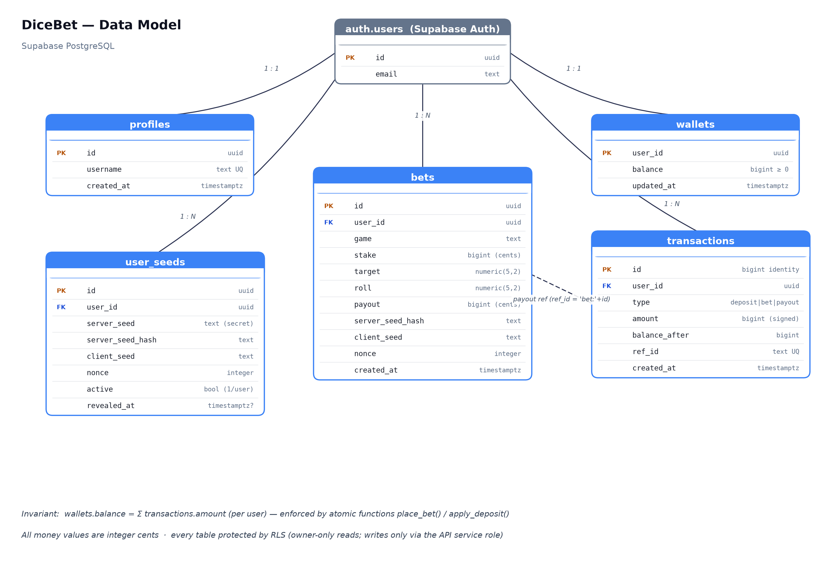
DiceBet – Data Modelling Diagram (docs/dicebet-data-model.png)
- profiles – public profile data (username), 1:1 with the authentication user;
- wallets – current balance per user (derived state, integer cents, non-negative);
- transactions – append-only ledger; signed amounts typed as deposit, bet, or payout, with balance_after snapshots and a unique external reference (ref_id) for idempotency;
- bets – immutable record of each roll: stake, target, roll, payout, and the fairness data (seed hash, client seed, nonce) that makes it verifiable;
- user_seeds – commit–reveal seed pairs; the plain server seed is only readable by the API and only exposed after rotation (revealed_at).

Data Flow – Placing a Bet
- The client sends stake and target with the user's session token;
- The API verifies the ES256 token against Supabase's public JWKS;
- The active seed pair is loaded and the next nonce is claimed atomically (nonce = nonce + 1);
- The roll is computed as HMAC-SHA256(serverSeed, clientSeed:nonce) → [0, 100);
- place_bet executes atomically: locks the wallet row, validates funds, inserts the negative bet transaction, inserts the bet, credits the payout transaction when winning, and updates the balance;
- The response returns the roll, payout, and new balance to animate the reveal;
- History and Fairness screens later read the same rows under Row Level Security.

Data Flow – Deposit
- The client requests a deposit; the API creates a Stripe Checkout session tagged with the user id;
- The user pays with a test card on Stripe's hosted page;
- Stripe calls the API webhook with checkout.session.completed;
- The API verifies the webhook signature against the endpoint secret;
- apply_deposit runs atomically and idempotently (unique ref_id = session id): inserts the deposit transaction and updates the balance;
- Webhook retries find the existing reference and change nothing.

Ledger invariant: for every user, wallets.balance always equals the sum of transactions.amount. Because every mutation flows through place_bet or apply_deposit — both atomic and row-locked — the invariant holds under concurrency, crashes, and webhook retries.

